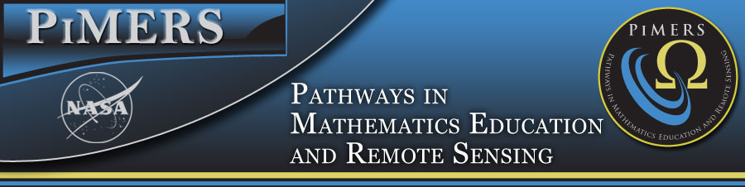
ECPI University Research Field Trip
April 15, 2016

To: PiMERS Middle School Participants
From: Dr. Darnell Johnson, Program Coordinator
Reason: NASA Langley Research Center Field Trip
Date: June 21, 2016

The agenda for the ECPI University Research Field Trip will be as follows:
Department from the side of Dixon Hall on the ECSU campus at 8:00 am on Tuesday, April 21, 2016
Arrive at the ECPI University Research Field Trip in Virginia Beach, VA at 10:00 am

10:00 am – 12:00 am Tour the ECPI University Tech Lab
12:00 noon LUNCH
1:00 pm Tour the Tech Lab
2:00 pm Depart for ECSU
3:30 pm Return to Dixon Hall on ECSU campus

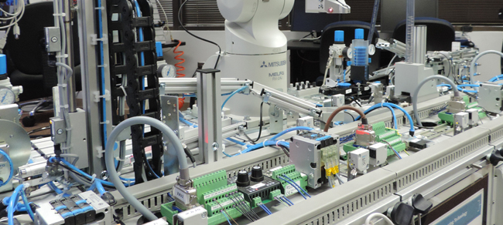
ECPI Technology Lab in Virginia Beach

Field Trip Staff
Program Coordinator: Dr. Darnell Johnson, PiMERS Education Coordinator
Administrative Assistant: Mr. Joel Hathaway
Please call 335-3696 should you have questions regarding this field trip.

